**Tema laborator 7**

--E1

-- d

DECLARE

TYPE refcursor IS REF CURSOR;

CURSOR c IS

SELECT j2.job_title, CURSOR

(SELECT e.last_name, e.first_name, e.salary

FROM employees e, jobs j

WHERE j.job_id = e.job_id AND

j.job_id = j2.job_id)

FROM jobs j2;

titlu_job jobs.job_title%TYPE;

nume_angajat employees.first_name%TYPE;

prenume_angajat employees.last_name%TYPE;

salariu employees.salary%TYPE;

referinta_cursor refcursor;

counter NUMBER(5);

BEGIN

OPEN c;

LOOP

FETCH c INTO titlu_job, referinta_cursor;

EXIT WHEN c%NOTFOUND;

DBMS_OUTPUT.put_line(titlu_job);

LOOP

FETCH referinta_cursor INTO nume_angajat, prenume_angajat, salariu;

EXIT WHEN referinta_cursor%NOTFOUND;

DBMS_OUTPUT.put_line(nume_angajat || ' ' || prenume_angajat || ' ' || salariu);

END LOOP;

DBMS_OUTPUT.new_line();

END LOOP;

END;

/

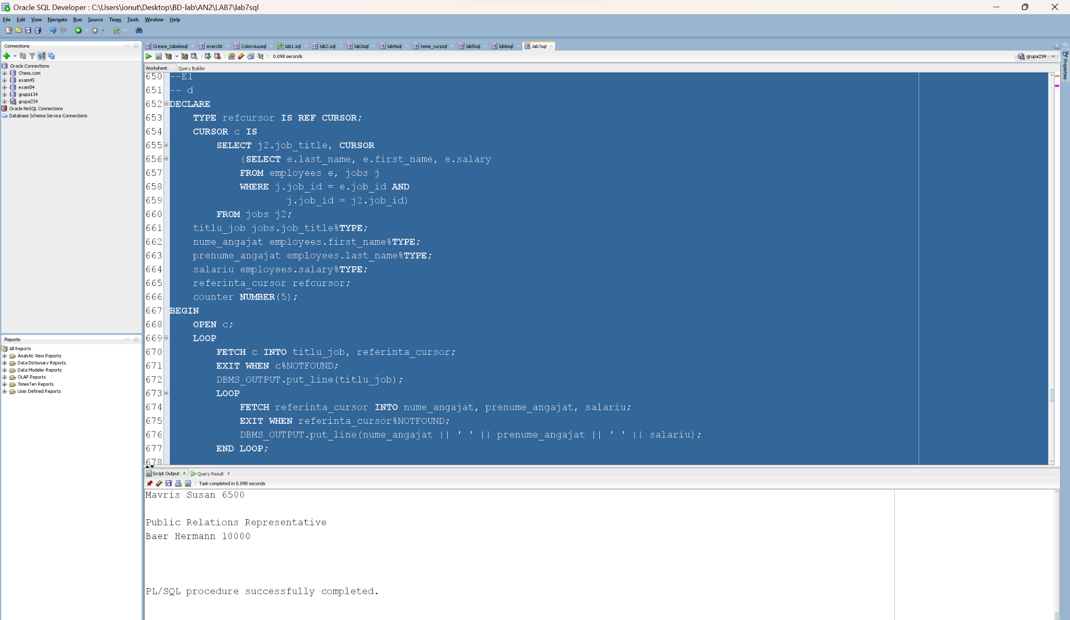

--2

DECLARE

TYPE tip_joburi IS TABLE OF jobs.job_id%TYPE;

CURSOR c (job_curent jobs.job_id%TYPE)IS

SELECT e.last_name, e.first_name, e.salary

FROM employees e, jobs j

WHERE j.job_id = e.job_id AND

j.job_id = job_curent;

numar_joburi NUMBER;

titlu_job jobs.job_title%TYPE;

nume_angajat employees.first_name%TYPE;

prenume_angajat employees.last_name%TYPE;

salariu employees.salary%TYPE;

joburi tip_joburi := tip_joburi();

numar_salariati NUMBER(5);

counter NUMBER(5);

salariu_total_job NUMBER(8,2);

salariu_mediu_job NUMBER(8,2);

salariu_total NUMBER(10,2) := 0;

salariu_mediu NUMBER(10,2) := 0;

counter_total NUMBER(5) := 0;

BEGIN

SELECT COUNT(*) INTO numar_joburi FROM jobs;

joburi.EXTEND(numar_joburi);

SELECT j.job_id BULK COLLECT INTO joburi FROM jobs j;

FOR i IN joburi.FIRST..joburi.LAST LOOP

SELECT job_title

INTO titlu_job

FROM jobs j

WHERE j.job_id = joburi(i);

counter := 0;

salariu_total_job := 0;

SELECT count(*)

INTO numar_salariati

FROM employees e, jobs j

WHERE e.job_id = j.job_id AND

j.job_id = joburi(i);

IF numar_salariati = 0 THEN

DBMS_OUTPUT.put_line('Niciun angajat ce lucreaza ca ' || titlu_job);

ELSIF numar_salariati = 1 THEN

DBMS_OUTPUT.put_line('Un angajat ce lucreaza ca ' || titlu_job);

ELSIF numar_salariati < 20 THEN

DBMS_OUTPUT.put_line(numar_salariati || ' angajati ce lucreaza ca ' || titlu_job);

ELSE

DBMS_OUTPUT.put_line(numar_salariati || ' de angajati ce lucreaza ca ' || titlu_job);

END IF;

OPEN c(joburi(i));

LOOP

FETCH c INTO nume_angajat, prenume_angajat, salariu;

EXIT WHEN c%NOTFOUND;

DBMS_OUTPUT.put_line(counter + 1 || ' ' || nume_angajat || ' ' || prenume_angajat || ' ' || salariu);

counter := counter + 1;

salariu_total_job := salariu_total_job + salariu;

counter_total := counter_total + 1;

END LOOP;

CLOSE c;

salariu_total := salariu_total + salariu_total_job;

IF counter = 0 THEN

DBMS_OUTPUT.put_line('Niciun angajat.');

ELSE

salariu_mediu_job := salariu_total_job / counter;

DBMS_OUTPUT.put_line('Salariul total e ' || salariu_total_job || ' cel mediu e ' || salariu_mediu_job);

END IF;

DBMS_OUTPUT.new_line();

END LOOP;

salariu_mediu := salariu_total / counter_total;

DBMS_OUTPUT.put_line('Salariul total la toti angajatii e ' || salariu_total || ' cel mediu e ' || salariu_mediu);

END;

/

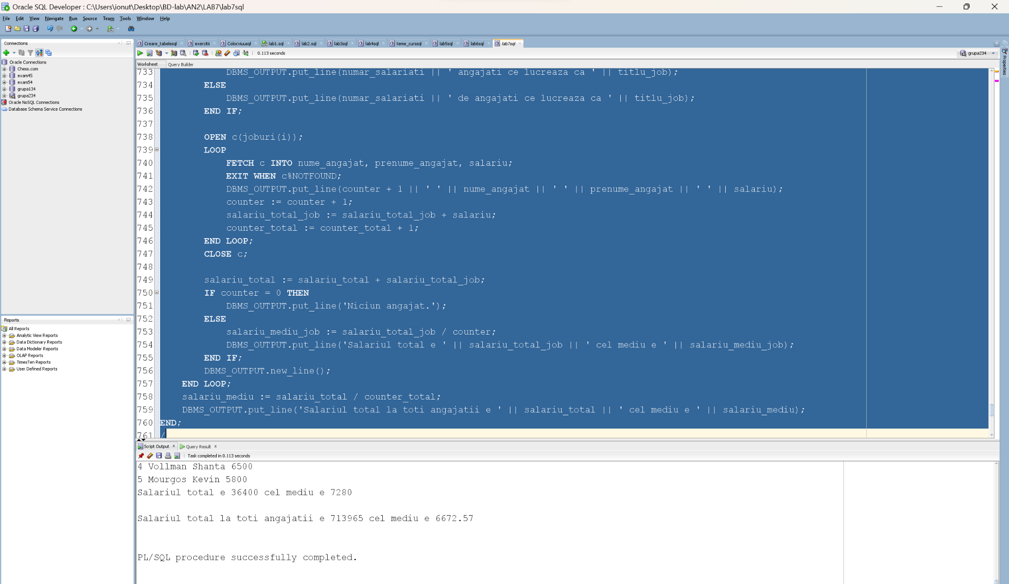

--6

DECLARE

CURSOR c_util IS (SELECT *

FROM utilizatori

WHERE id_utilizator IN (1,2,3,4));

CURSOR c_utilizator (u_id utilizatori.id_utilizator%TYPE) IS (SELECT * FROM utilizatori

WHERE id_utilizator = u_id);

u_id utilizatori%ROWTYPE;

u_utilizator employees%ROWTYPE;

BEGIN

OPEN c_util;

LOOP

FETCH c_util INTO u_id;

EXIT WHEN c_util%NOTFOUND;

DBMS_OUTPUT.PUT_LINE(u_id.nume_utilizator);

OPEN c_utilizator(u_id.id_utilizator);

LOOP

FETCH c_utilizator INTO u_utilizator;

EXIT WHEN c_utilizator%NOTFOUND;

DBMS_OUTPUT.PUT_LINE(u_utilizator.id_utilizator);

END LOOP;

CLOSE c_utilizator;

END LOOP;

CLOSE c_util;

END;

/

